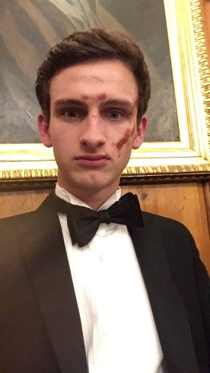

**Sam for Trea$urer**

# Who am I?

**I am:**

1. A second year Engineering undergraduate
2. A fully-fledged award-winning rower of the 2017 NM2 crew
3. 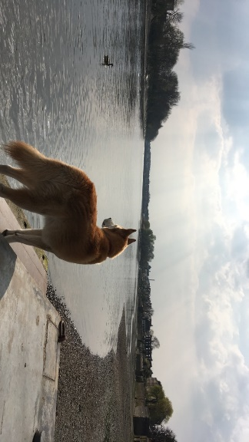A keen and long-standing rower of M2
4. Proud to share the same name as our boathouse doggo, the goodest boi on the cam:

**I am not:**

1. As cool as our boathouse doggo (but being an engineer makes up for this)

# Why me?

Photo creds: me

1. I like maths (I’m an engineer)
2. I’m personable and enthusiastic - always an active participant in post-outing debriefs
3. I’m organised and dependable – successfully coordinated matching stash for M2 in 2018 as stash secretary (originality creds to Adam)
4. I know all the lyrics to ‘row row row your boat’
5. I can eat chocolate from my forehead without touching it

# What I aim to do

1. Keep on top of treasurer duties and respond to matters promptly
2. Bring my enthusiasm to a committee position within CCBC
3. Collaborate with CCBC members to ensure we go from strength to strength
4. Go sub 7 on a 2k

Signed:

Proposed:

Seconded: